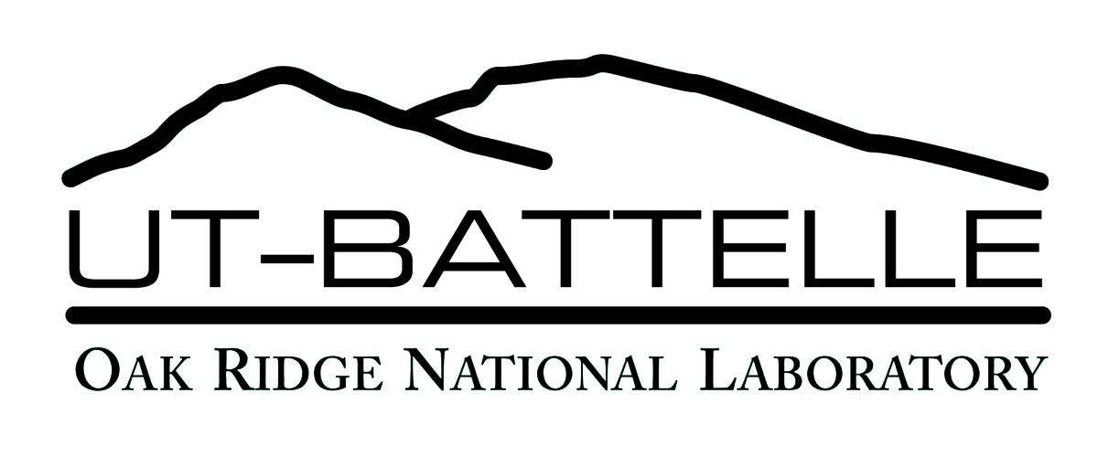
EMPLOYEE PROGRAMS
Matching Gifts Fund

The Program
Each year, UT-Battelle employees generously give their time and talents to a variety of community organizations. The Matching Gifts Fund is designed to further encourage employees to support local nonprofit organizations with personal financial donations.
Who is Eligible to Participate?
The Matching Gifts Fund is open to current UT-Battelle employees with a minimum of three months of service and will provide a minimum match of $50 and a maximum match of $500 annually. Retirees, subcontractors, and vendors are not eligible to participate.
Eligible Gifts
Donations to organizations in the categories below may be eligible for matching funds. Organizations must operate in the counties in which UT-Battelle employees work and/or live. The organizations must be tax-exempt under Section 501(c)3 of the Internal Revenue Code. Matching contributions will not exceed $1000 per organization per year.
Eligible categories:
- Arts and Cultural
- Community and Environmental
- Health and Human Services
- Public/Private Schools (Grades Pre K-12)
Ineligible Contributions
We limit Matching Gifts to the eligible categories listed. We do not match gifts to these types of organizations:
- United Way and other combined appeals (outside the existing corporate contribution as part of the ORNL United Way Campaign)
- Religious or political organizations as well as gifts to seminaries, theological institutions, and Bible colleges
- Organizations whose policies are inconsistent with national equal employment opportunity policies or discriminate against a person or a group on the basis of race, ethnicity, religion, national origin, sex, disability, gender, political affiliation, or age
- Fraternities, sororities, honor societies and campus organizations
- Intermediary funding groups that raise money to distribute to other groups
- Private foundations and/or individuals
- In-kind gifts
- Organizations whose purpose or policies are inconsistent with UT-Battelle’s corporate giving philosophy and guidelines
To Participate
To request a matching gift, employees should complete Section A on the reverse side of this form and mail it, along with their gift, to the eligible organization.
For walks, runs and bike-a-thons, only the employee’s own donation will be matched. A copy of the employee pledge sheet must be attached to this form along with the employee’s contribution.
An authorized official of the nonprofit organization should complete Section B and return the form to the Matching Gifts Program Coordinator. After receiving the completed form, the program coordinator will verify the eligibility of the organization and the gift. The appropriate matching contribution will be mailed to the organization at that time.
The company reserves the right to amend, revise, suspend or terminate this program at any time.
Questions should be directed to the Matching Gifts Program Coordinator at 865-241-9309 or community@ornl.gov.

EMPLOYEE PROGRAMS
Matching Gifts Fund

Section A: Employee Information
This section is to be completed by the employee. Please print.
Name
Address
City |  | State |  | Zip
( )
Telephone
E-mail

Information About Your Contribution:
Name of Organization
Contribution amount $

Type of Organization (check one):
Arts and Cultural
Community and Environmental
Human Services and health
Schools (grades K-12)
Date of contribution / /
(month/day/year)
This is my own contribution, and it is not payment for tuition, services, subscriptions, tickets, memberships, dues, or other exclusions explained on the reverse side of this form.
Signature
Employee ID number
Matching gift applications must be processed within one year of the date of the gift. After one year, the gift will no longer be eligible for a match.
(REV June 2017)
Section B: Organization Information
The contribution described in Section A of this form was received by the organization below. This organization is a nonprofit group that has been determined tax-exempt under Section 501(c)3 of the Internal Revenue Code, and contributions made to this organization are tax-deductible by individuals and corporations on this income tax returns. The organization qualifies for the UT-Battelle Matching Gifts Fund as outlined on the reverse side of this form.
This section to be completed by the organization.
Please print.
Organization
(as name appears on 501(c)3 IRS Determination Letter)
Federal Tax ID Number
Address
City |  |  | State |  |  |  | Zip
( )
Telephone
( )
Fax
Date contribution received | / |  |  |  | /
Name
Signature
Title
Send the completed Matching Gifts Fund request form to:
Community@ornl.gov
OR
Matching Gifts Program Coordinator
P.O. Box 2008
Oak Ridge, TN 37831-6266
Section C
To be completed by UT-Battelle.
Date received / / (month/day/year)
Date paid / / (month/day/year)
Amount paid $

